

Arms Management system

Assignment 3 & 4



December 20, 2018

Comsats university islamabad

Group Members:

* Ammar Rashid Malik FA18-BSE-011
* Aseed Ali Khokhar FA18-BSE-015

Output of Program:

Output 1: Entering Menu

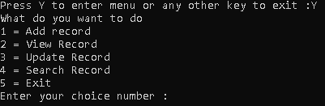

Output 2: Adding Records

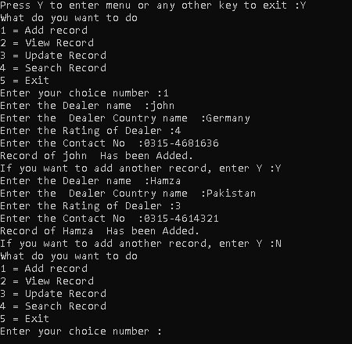

Output 3: Viewing Records

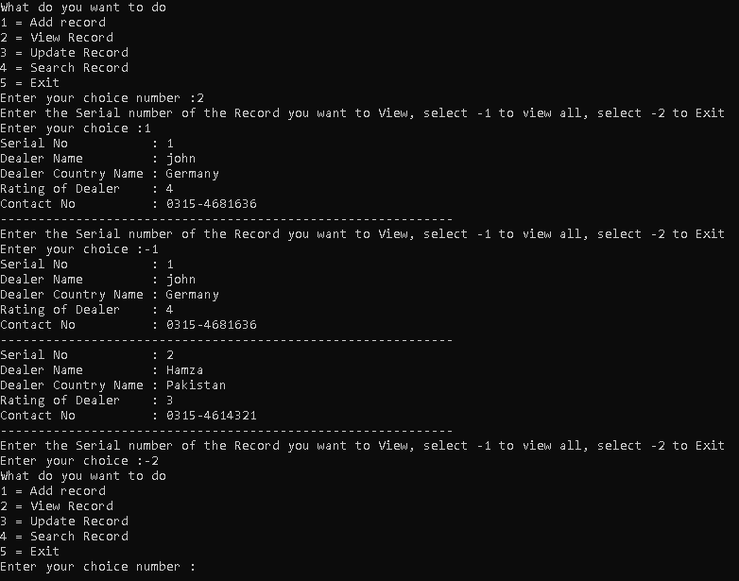

Output 4 Updating Records

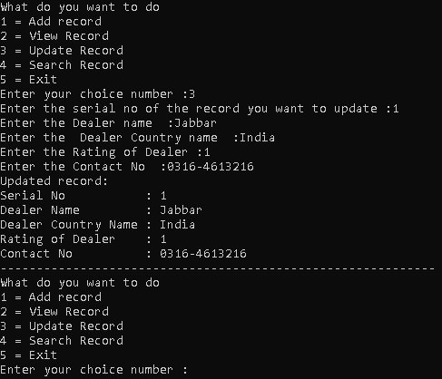

Output 5: Searching Records

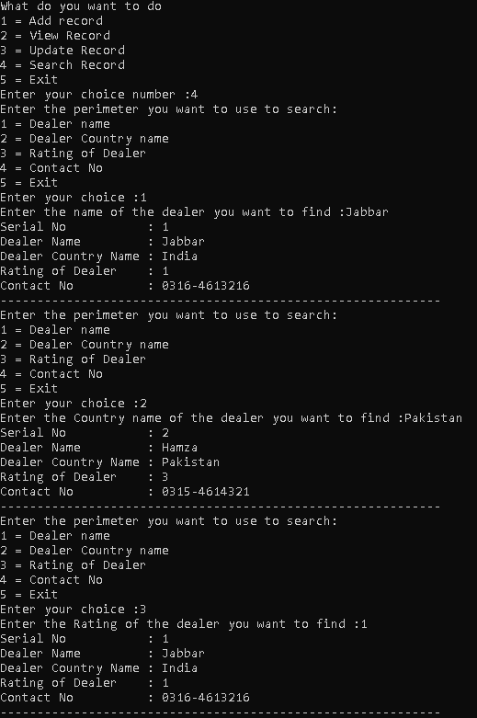

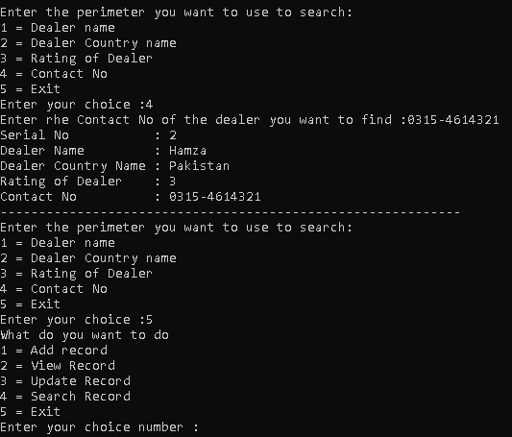

Output 6: Exiting Program

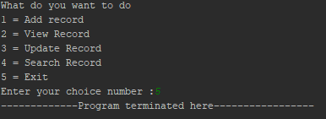

THANK YOU!!!